

**[companyname]**

Dated <To>

**TO WHOM IT MAY CONCERN**

This is to certify that <Name> s/o <fname> was employed with [companyname] from <From> to <To> at [companyproject] During their tenure he was with us as a <Designation> .

Throughout their time with [companyname], he demonstrated remarkable dedication and professionalism. They consistently met or exceeded expectations and contributed significantly to our team. He was known for their excellent problem-solving skills, ability to work collaboratively, and strong work ethic.

We wish he all the best in their future endeavors and are confident that they will succeed in any role they pursue.

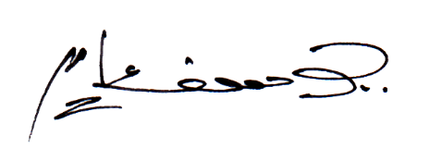

**[contact]**

**[companyname]**

**HR**

**MANAGER**

**MANAGER**

**[companyaddress]**